1. Analysis Overview

The quality of the data which was given to me was high. I was able to glean many important pieces of information, and ask myself many important questions in addition to the ones that were asked of us.

Essential take-aways:

* Employee engagement has very little, if anything, to do with the amount of time the employee has been at a company. Employee satisfaction frequently starts high, drops drastically around the 20 month mark of their employment, and then raises up again after about 80 months.
* An area of focus for improving diversity could be to hire more people of hispanic or latino origin.
* There were some interesting patterns found in the analysis of employee satisfaction when associated with various other metrics.
  + An employee’s performance score had little to no affect on their tenure at the company or their satisfaction. (see fig. 8 & 9)
  + The manager seemed to make a difference and there was a noticeable range of employee satisfaction based on the manager. (see fig.10)
  + The more special projects an employee works on, the more satisfied they are at the company. (see fig. 12)

1. Equitable Pay Analysis

The salary distribution according to gender presents some interesting contrasts. While the company has more female employees and the highest paid employees are female, the median for male employees is higher. The interquartile range also starts and ends higher.

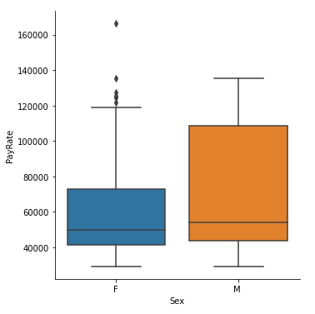

*Figure 1,Pay rate between males and females*

According to the data, you are likely to be better paid as a male employee, but you are unlikely to make the highest possible salary overall.

1. Employee Longevity Clusters

I found no correlation between employee engagement and months worked.*Figure 2* However, I found that people usually feel less satisfied with their workplace between 20 and 80 months there. *Figure 3* I suspect that there is an incentive at 80 month’s work time as workplace satisfaction jumps greatly.

I found no correlation between engagement and satisfaction compared to the amount of months worked.

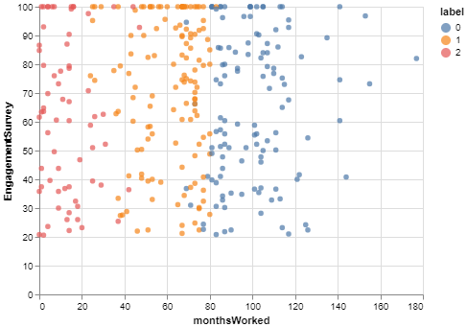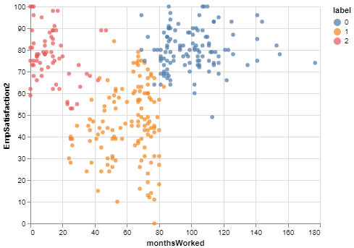

*Figure 2, Employee Engagement/Months Worked | Figure 3, Employee Satisfaction/Months Worked*

The graph below (fig. 4) was an example of the K Elbow Clusters that I used to determine how many clusters there should be. Despite the elbow being inverted, any more clusters than 3, which I found in the center of the graph and where the elbow begins to soften off, removes any semblance of coherence among the data which I collected and graphed.

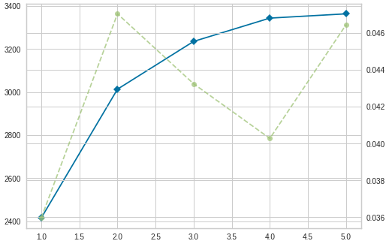

*Figure 4, K Elbow clusters 1-6*

1. Diversity

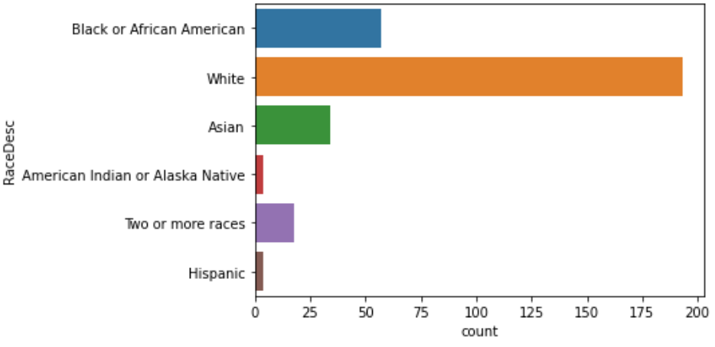

18.38%

62.26%

10.97%

1.29%

5.81%

1.29% ( 9.03% Of Any Race)

*Figure 5, Race Amounts and Percentages*

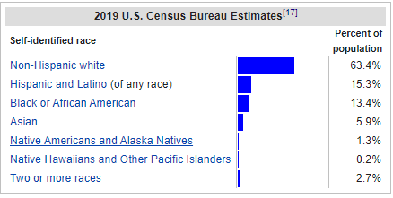

*Figure 6, Diversity Statistics from the U.S. Census Bureau*

Compared to the National Distribution from the 2019 Census Bureau Estimates, I am within a single percentage point of the national average of Whites and Native Americans/Alaska Natives. and Native American and Alaska Native percentages. Black/African American Percentage is about 5% higher than the census distribution, as is Asian Percentage.

Only about 1% of ou employees identify specifically as of Hispanic or Latino origin, however the Census percentage takes into account those who identify as other races as long as they have hispanic or latino origin. When this is taken into account, I am 6% lower than the census at 9%.

Generally, I appear to be doing well with diversity. An area of focus could be hiring more people with Hispanic or Latino origins.

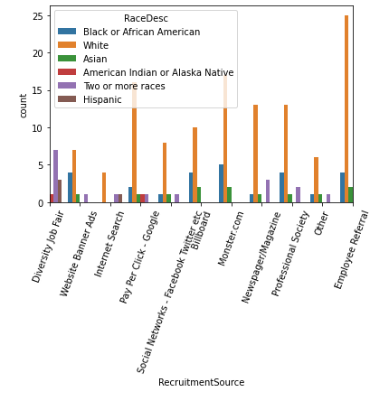

*Figure 7, Racial makeup based on recruitment source*

A cursory analysis of the data indicates that diversity job fairs are, far and away, best tool for promoting diversity directly. This would be the most efficient tool to use if I need to foster more diversity.

1. Employee Satisfaction and Engagement Survey Analysis

When discussing patterns in employee satisfaction, it became clear what pieces of data to be analyzed. The following categories were chosen due to their relevance to an employee’s day to day life as well as their ability to help an employee stand out.

Performance Score

A key component of an employee’s work is how their work is received and if that work meets the standards the company has set forth. Two different types of analysis were performed on this data. First, an observation of performance scores related to the number of months worked was conducted. No apparent correlation was found (see fig. 8), meaning the performance score does not have an effect on the amount of time an employee is at the company.

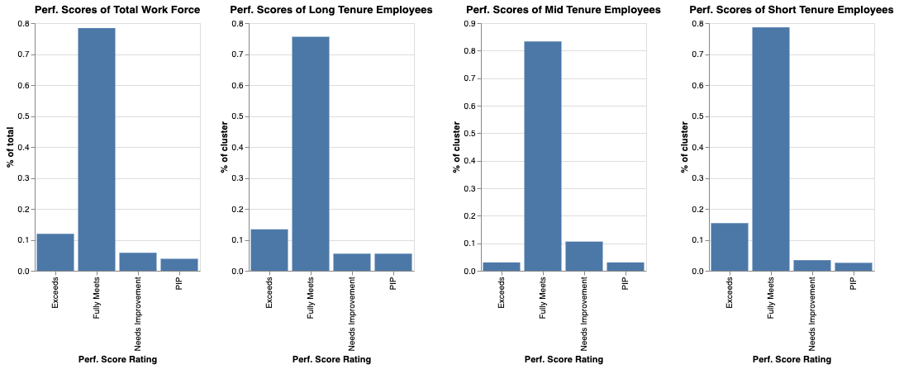

*Figure 8, Performance Scores based on tenure cluster*

Second, a comparison of the performance score for employees was made to their satisfaction level. This comparison also shows very little relationship between performance score and employee’s satisfaction (see fig.9). One interesting note worth mentioning is that the category with the widest range, and only outlier, was the “Fully Meets” category. There was not enough data to make a concrete conclusion as to why this is but one would think that those that fully meet the company’s expectations would be satisfied as well. It looks as though this is not always the case.

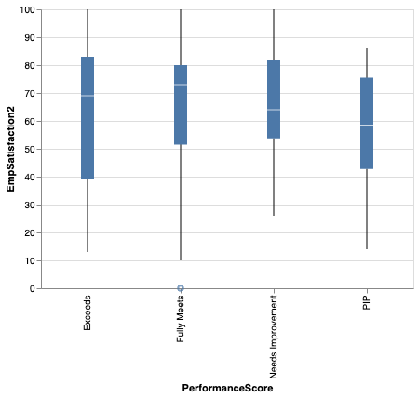 *Figure 9, Performance Scores related to employee satisfaction*

Manager

Another key factor analyzed was the effect that a manager had on the satisfaction of their employees. Below it can be seen that the manager can have a significant impact on the satisfaction of the employee (see fig. 10).

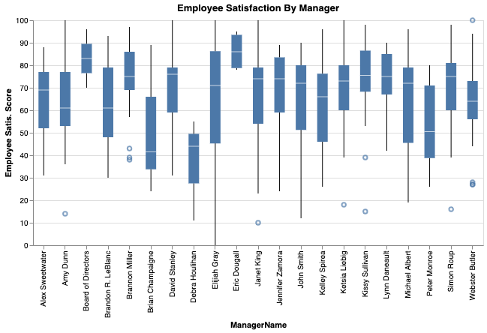

*Figure 10, Employee satisfaction ranges based on manager*

This analysis can show several things. First, the company can make tailored goals and decisions based on the satisfaction of specific teams. Second, upper management knows immediately where to focus their morale efforts by team. Third, if goals have been set and things are still not improving then a team can be further analyzed and a decision can be made to move on from the manager, shift them to a new role or remove a team member from the team. This analysis helps to narrow the problem down from the whole company or large groups down to specific teams where accountability can be instituted.

A brief note about further potential analysis. It can be seen that the team led by the Board of Directors is one of the most satisfied in the company. It would be interesting to get a hierarchy of the managerial relationships in this data and then analyze them for changes in satisfaction. An example might be, if the teams furthest down the hierarchy feel unhappy while teams at the top of the hierarchy are happy then there may be a communication issue or some other issue to be identified. Either way, [S.M.A.R.T goals](https://www.mindtools.com/pages/article/smart-goals.htm) can be set as a company with this analysis.

Involvement in Special Projects

*. 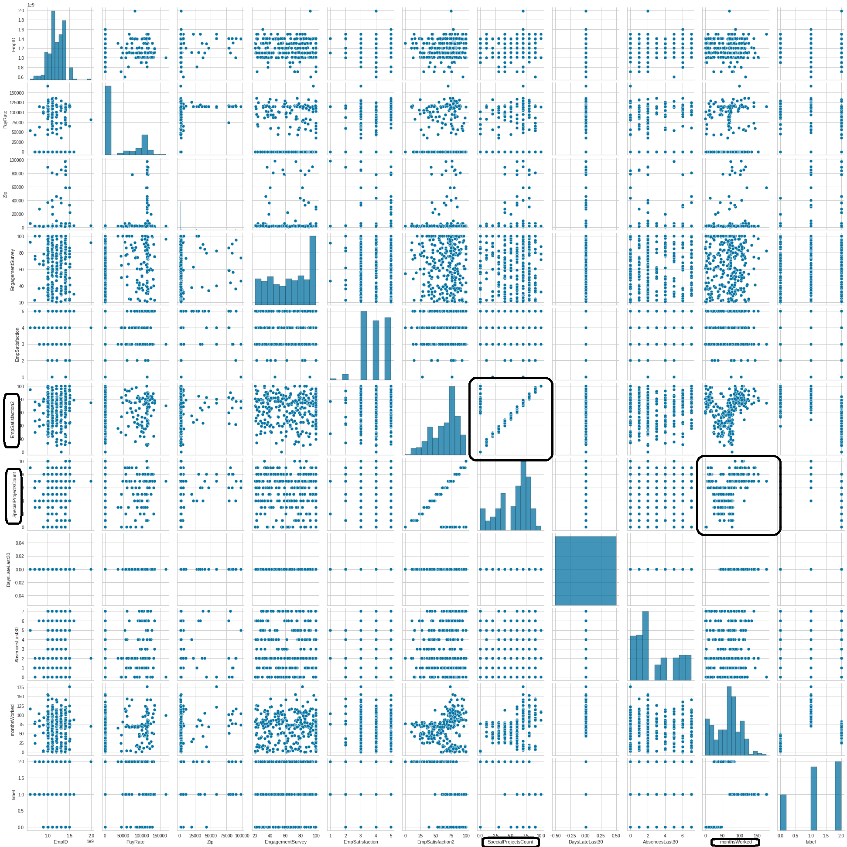*

*Figure 11, Pair plot for all data in the dataset*

Above is a pairs plot that shows the relationship between the factors in the dataset. EmpSatisfaction2 and monthsWorked seems to have a pattern with SpecialProjectCount. Below is a graph that better illustrates this (see fig.12).

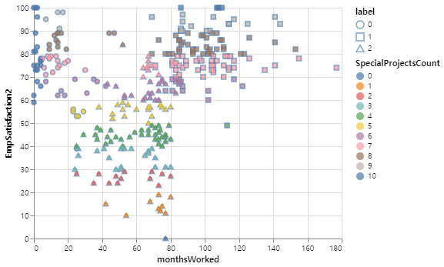

*Figure 12, Employee Satisfaction by tenure with emphasis on special projects*

As you can see from the above chart, for employees tenured at least 20 months, there is a direct, nearly linear relationship between the number of special projects given to an employee and their level of satisfaction. Those that worked on many special projects are, or were, very satisfied and the opposite is true for the employees that were not involved in very many, or any, special projects.

1. Conclusion and Caveats

The analysis above has led to several conclusions that were touched on in the *Analysis Overview*. These conclusions relate to the pay gap, diversity and employee satisfaction questions that were asked of us by the company.

The main conclusion from Section II is that men are paid higher on average, but women are more likely to be the highest paid. Superlative pay (most and least) belongs to the women, but comparatively higher pay belongs to the men.

The largest takeaway from Section III, is that when it comes to engagement you can not assume that those who have been with this company for the longest time are the most engaged. However, with the information that I’ve found in section V, there is a safe assumption that those with special projects are generally more engaged. What I may learn from this then, is that engaging with the employees and helping them to find work that they may enjoy more should help to improve engagement, regardless of the time worked at the company. Doing so may improve engagement, productivity, and satisfaction in their jobs.

When looking for patterns related to the satisfaction of employees, three major conjectures can be made. First, the performance score of an employee has no effect on the tenure of the employee or on the satisfaction of that employee. Second, the manager of the employee certainly has an effect on their satisfaction. Those managers that are struggling at maintaining high levels of employee satisfaction deserve some extra attention from the upper management. Lastly, the number of special projects that an employee has been involved in almost perfectly correlates to their satisfaction. If the company wants happier employees, the employees need to be involved in more special projects and have more responsibility given to them.

I am happy to present this analysis to the board and hope that the recommendations contained here will be taken to heart and help the company grow even more in the goals that have been set.